Ideation Phase
ServiceNow UI Policy – High Impact Control

Date | 01 October 2026
Team ID | SWTID-2026-7028
Project Name | Implement Client Script & UI Policy (Incident)
Maximum Marks | 4 Marks

ServiceNow UI Policy Configuration:
The first milestone focuses on configuring a ServiceNow UI Policy for Incident records. The policy is designed to apply additional controls when the Incident impact is set to High. The configuration includes defining the policy, setting the condition, making the Assignment group mandatory, and enabling Reverse if false.
Use this milestone workflow to understand the configuration steps from accessing UI Policies through reviewing and submitting the High Impact Control policy.
Reference: Project Milestone 1 – High Impact Control UI Policyhttps://www.mural.co/templates/brainstorm-and-idea-prioritization
Step-1: Access ServiceNow, Create the UI Policy and Define the Problem
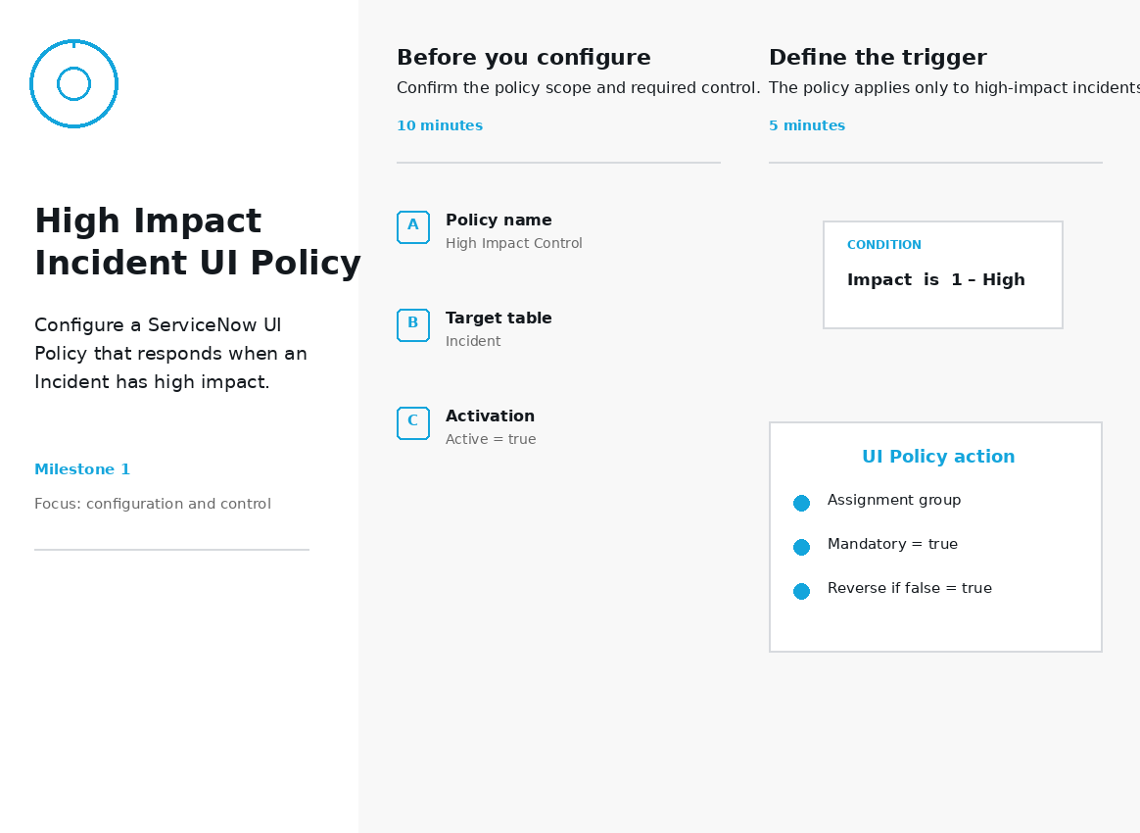

Step-2: Configure the High Impact Condition and UI Policy Action
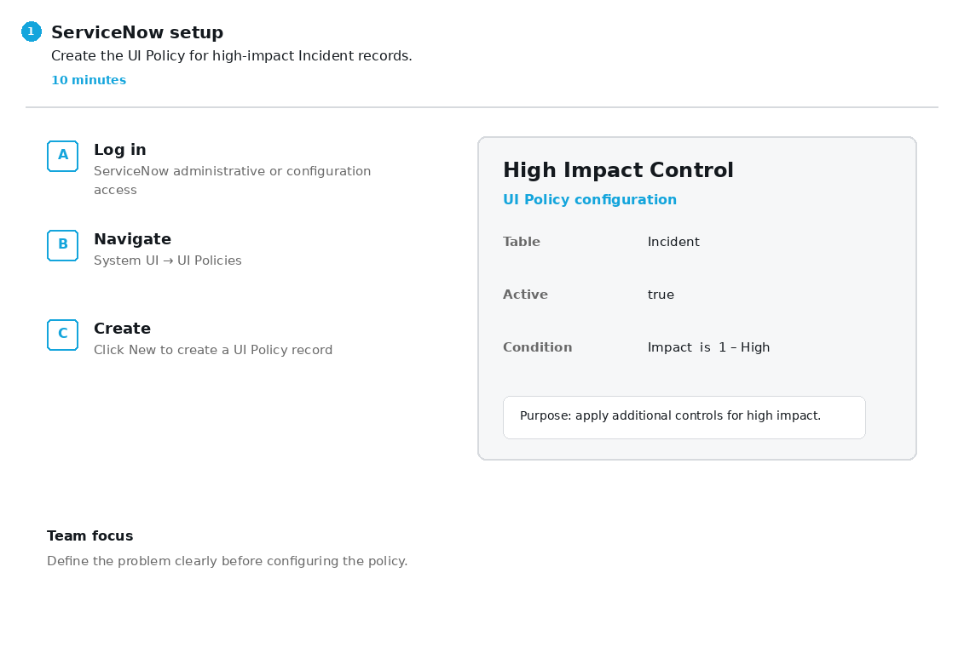

Step-3: Review, Validate and Submit the UI Policy
